ANALYSIS OF CORPORATE ANNOUNCEMENTS ON STOCK PRICE AND TRADING VOLUME

1. Introduction
Corporate announcements can introduce new information into the market and may affect stock prices, trading volume, and short-term volatility. This study analyzes the market response to BSE corporate announcements using announcement-level data and one-minute OHLCV market data for five stocks: RELIANCE, HDFCBANK, NYKAA, HAL, and RVNL.
The analysis combines announcement fields such as company, category, subcategory, subject, narrative information, and dissemination timestamp with market variables including open, high, low, close, volume, and open interest.
2. Objective
The main objective is to analyze how different types of corporate announcements are associated with changes in stock price and trading activity.
The analysis specifically aims to:
- Clean, validate, and correctly align announcement and market data using the first complete one-minute bar at or after dissemination, while handling pre-market, in-session, post-market, weekend, and non-standard sessions.
- Identify and cluster related announcements representing the same underlying event and classify them into meaningful subject groups.
- Measure and compare price returns, volume changes, and volatility across short- and long-term horizons, subjects, and stocks using appropriate statistical methods.
- Analyze price-conditioned PEAD following independent financial-results events to determine whether the initial price reaction continues over subsequent trading sessions.
3. Scope of Analysis
The study is restricted to the five supplied companies and the provided announcement and one-minute market datasets. Price impact is measured over the first 5, 30, and 60 minutes, through the trading-session close, and over D+1, D+5, D+10, and D+20 trading sessions.
For earnings events, the analysis examines the initial D0 reaction and subsequent returns through D+1, D+3, D+5, D+10, and D+20. As earnings-surprise data was unavailable, the analysis focuses on price-conditioned post-earnings drift.

4. Dataset Description
The analysis uses BSE corporate announcements and one-minute OHLCV data for five stocks: RELIANCE, HDFCBANK, NYKAA, HAL, and RVNL. The announcement dataset contains 2,530 records and 28 fields, including announcement details, subject, category, narrative information, and dissemination timestamps. The market files contain open, high, low, close, volume, and open interest (OI) data.
5. Data Preparation and Validation
The announcement timestamps were parsed using mixed-format datetime handling. DissemDT was treated as the primary event timestamp, with DT_TM retained as the documented fallback. Under standard parsing, 2,519 DissemDT values were parsed and 11 were initially unparsed. Inspection showed that these 11 records contained corresponding DT_TM values identical to DissemDT. Mixed-format parsing successfully handled these representations, resulting in 2,530 valid DissemDT values. The final "event_time" field therefore contained 2,530 valid timestamps with no missing values.
Each announcement was subsequently aligned to the first complete one-minute market bar beginning at or after dissemination, avoiding the use of a bar that had started before the announcement.
6. Data Quality Checks
The datasets were checked for timestamp issues, missing and duplicate records, invalid OHLC values, zero-volume observations, and incomplete event windows. Material exclusions were recorded rather than silently discarded.
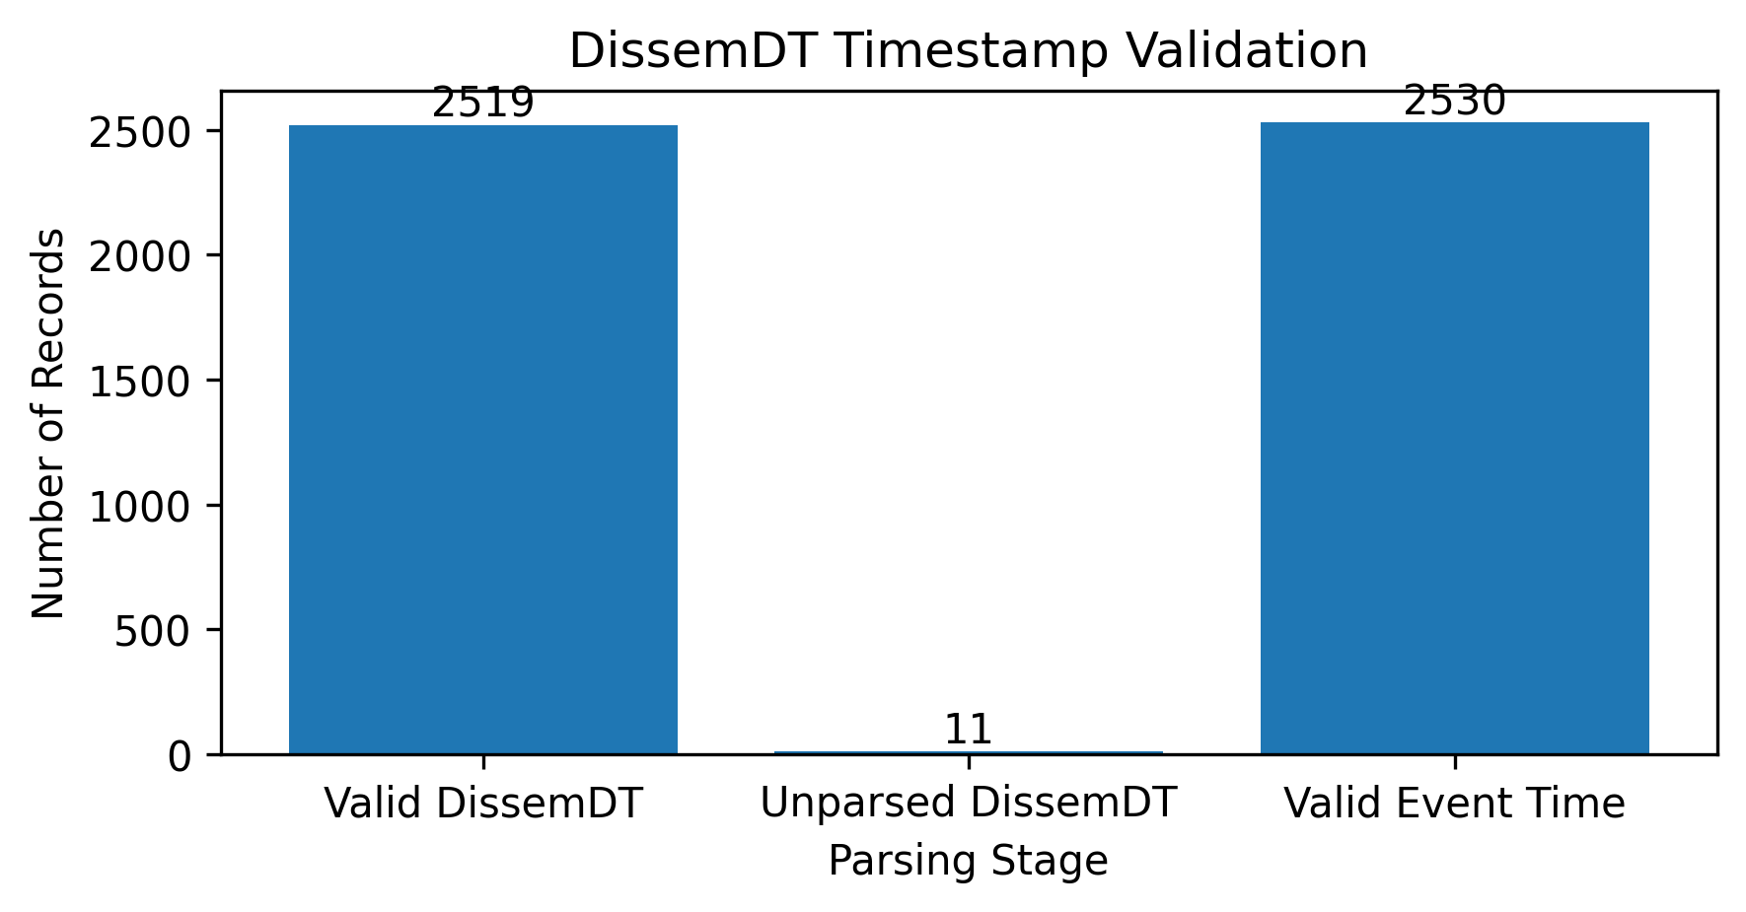
Initially, 11 DissemDT values were unparsed under standard parsing; their corresponding DT_TM values were identical, and mixed-format parsing resulted in 2,530 valid event_time values.
7. Event Alignment
Announcements were aligned with the first complete one-minute market bar beginning at or after dissemination time. Outside-session announcements were mapped to the next available trading session.
8. Event Clustering
Closely timed, related announcements from the same company were grouped using company, announcement type, subject information, and time proximity. This reduced potential double-counting. The 2,528 announcements formed 2,396 rule-based event clusters.
9. Subject Taxonomy
Announcements were classified into seven groups using announcement subject fields: Financial Results, Board / Management, Investor Communication, Corporate Actions, Orders / Business, Regulatory / Compliance, and Press / Public Updates.
Independent Event Clusters by Subject Group
Subject Group | Independent Events
Press / Public Updates | 943
Regulatory / Compliance | 483
Investor Communication | 315
Board / Management | 258
Corporate Actions | 252
Orders / Business | 135
Financial Results | 52

Figure 2 : Independent Event Clusters by Subject Group
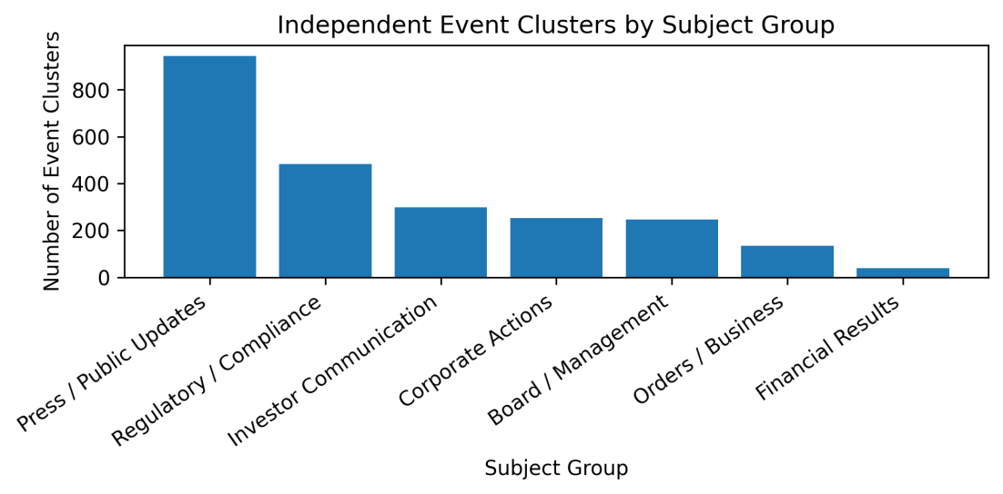

10. Price Impact Methodology

Price reaction was measured using returns over 5-minute, 30-minute, 60-minute, market-close, and subsequent daily windows. Short-term returns were small and statistically insignificant, while the average market-close return was +0.177% and statistically significant.

11. Volume Methodology

Volume impact was measured relative to the normal trading activity around each announcement. The average volume impact was +81.54% and was statistically significant. However, the median impact was only +0.42%, indicating that extreme volume spikes influenced the mean substantially.

12. Volatility

Event-window volatility was calculated as the standard deviation of 5-, 30-, and 60-minute returns. The mean volatility was 0.410, with a median of 0.271.

13. Statistical Methodology

One-sample t-tests were applied to determine whether average returns and volume impact differed significantly from zero. Statistical significance was assessed using the resulting p-values.

14. Strong Impact Definition

An event was classified as having a strong price impact when the absolute market-close return was at least 2%. Under this definition, 597 of 2,528 events (23.6%) showed strong price impact.

15. Overall Impact Results
The analysis shows that corporate announcements had a stronger effect on trading activity than on immediate price returns. Short-term returns were generally small, while the market-close return showed a statistically significant positive average of +0.1774%. Average volume impact was +81.54%, indicating increased trading activity around announcements.

16. Subject-wise Results
The magnitude of the reaction varied considerably across announcement categories. Orders / Business produced the highest average market-close return (+0.903%), followed by Press / Public Updates (+0.269%). Financial Results showed the lowest average return (−0.416%) but the highest average volume impact (+476.51%). This indicates that earnings-related announcements generated substantial trading activity despite their negative average price reaction.

Subject –wise Event Impact
Subject Group | Events | Mean Close Return (%) | Mean Volume Impact (%) | Strong Impact Events
Orders / Business | 135 | 0.903 | 239.642 | 43
Press / Public Updates | 943 | 0.269 | 78.225 | 254
Investor Communication | 315 | 0.130 | 120.972 | 89
Regulatory / Compliance | 483 | 0.064 | 7.233 | 65
Corporate Actions | 252 | 0.032 | 5.526 | 41
Board / Management | 258 | 0.006 | 101.137 | 75
Financial Results | 52 | -0.416 | 476.515 | 30
Total | 2,396 | — | — | 597

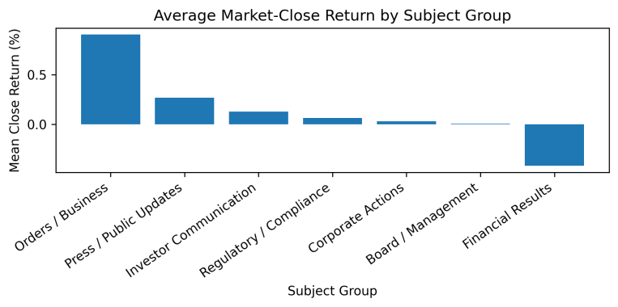
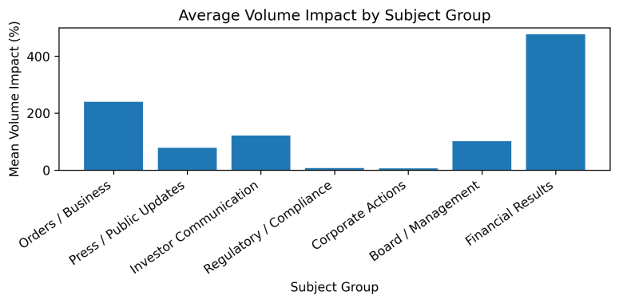

17. Stock-wise Results
PEAD results varied substantially across stocks. HAL and RVNL showed the strongest positive post-earnings drift, while HDFCBANK remained negative. RELIANCE showed relatively weak drift, and NYKAA became more positive at longer horizons.

Table 3: Stock-wise PEAD Results
Stock | Events | D0 Mean (%) | D+1 Mean (%) | D+5 Mean (%) | D+10 Mean (%) | D+20 Mean (%)
HAL | 11 | 0.859 | 0.280 | 1.623 | 1.552 | 6.341
HDFCBANK | 6 | -0.397 | -0.101 | -1.132 | -0.884 | -2.013
NYKAA | 12 | 0.172 | -0.402 | 0.694 | 1.294 | 3.727
RELIANCE | 12 | 0.048 | -0.333 | 0.505 | -0.256 | 0.556
RVNL | 11 | -2.189 | -0.632 | 2.415 | 2.748 | 3.205

Note: Event counts represent independent earnings events. The usable sample decreases at longer horizons because recent announcements do not yet have complete D+10 or D+20 trading-session windows.

18. PEAD Introduction
Independent financial-result announcements were examined to test whether the initial earnings-day price response was followed by movement in the same direction over subsequent trading sessions. This is treated as price-conditioned post-earnings drift because analyst-expectation or earnings-surprise data was not available.

19. Earnings Event Identification
53 financial-result announcements were identified initially. After correcting for related announcements and clustering, 52 independent earnings events remained. All 52 had sufficient market data for the PEAD analysis.

20. D0 Methodology
D0 represents the first trading session in which the earnings information could be acted upon. The initial reaction was measured from the last available pre-announcement price to the D0 closing price. Subsequent returns were measured at D+1, D+3, D+5, D+10 and D+20.
21. Post-Earnings Announcement Drift Results

Across 52 independent earnings events, the average D0 reaction was -0.276%, followed by -0.256% at D+1 and positive average returns from D+3 onward. The mean drift reached 1.000% at D+5 and 2.675% at D+20.
However, the results do not provide strong evidence of statistically significant PEAD at the 5% level. The D+20 result was the closest to significance (p = 0.057), while earlier horizons were statistically insignificant.
The percentage of events continuing in the initial D0 direction increased from 53.8% at D+1 to 61.5% at D+5 and 74.0% at D+10, before declining to 63.3% at D+20. This suggests some persistence in the price-conditioned direction, but the evidence is not sufficiently consistent to establish strong post-earnings drift.
Stock-level results were heterogeneous. HAL showed the strongest positive D+20 drift (+6.341%), followed by NYKAA (+3.727%) and RVNL (+3.205%). HDFCBANK remained negative at D+20 (-2.013%), while RELIANCE showed only a small positive drift (+0.556%).
Overall, the evidence indicates that longer-horizon movement exists after some earnings announcements, but it is inconsistent across stocks and does not provide conclusive evidence of systematic PEAD.
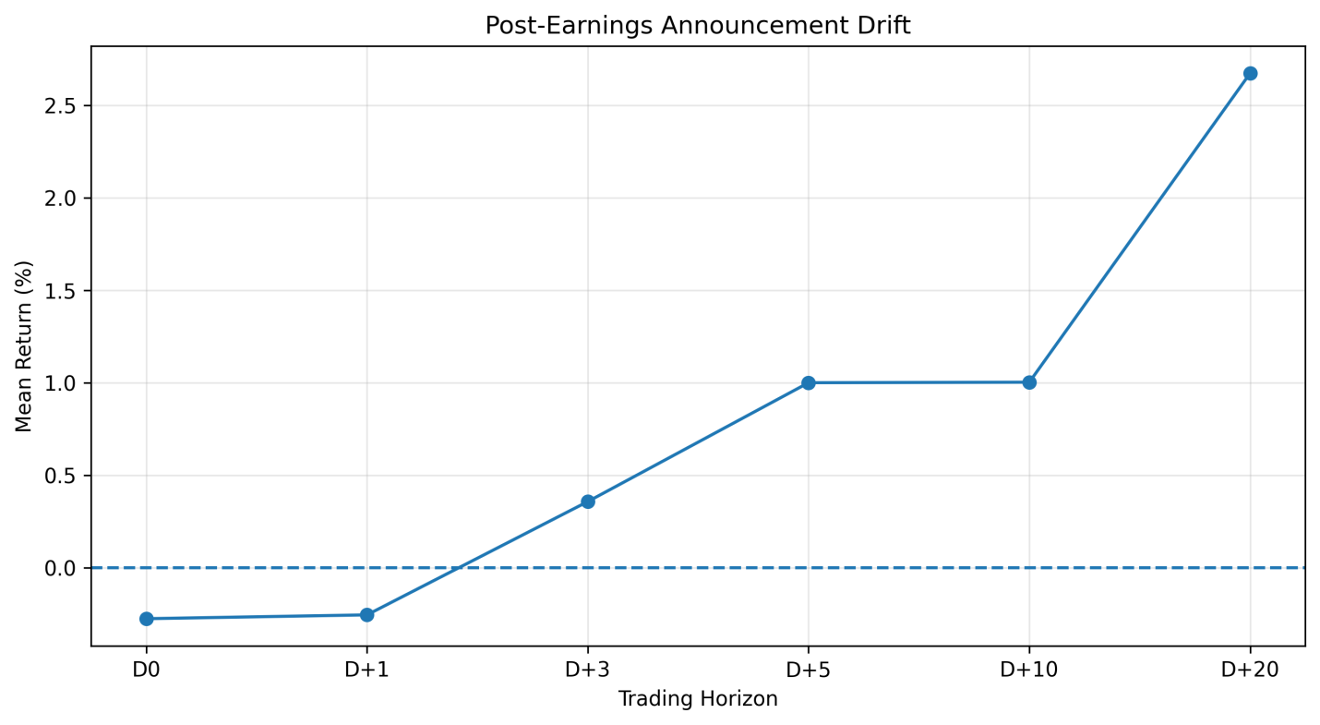
Figure 5 : Mean post-earnings returns across D0, D+1, D+3, D+5, D+10 and D+20. The figure illustrates the gradual increase in pooled mean returns, while statistical testing indicates that the observed drift is not statistically significant at the conventional 5% level.

Key Findings
1. 2,396 independent events were identified across seven subject groups after event clustering and correction.
2. Orders / Business announcements had the highest mean close return (+0.903%), while Financial Results had the lowest (-0.416%).
3. Financial Results generated the highest mean volume impact (+476.515%), indicating substantially elevated trading activity.
4. RVNL recorded the highest stock-level mean close return (+0.563%), followed by HAL (+0.403%).
5. Overall mean close return was +0.177%, while the median was +0.038%, indicating some influence from large positive observations.
6. Mean volume impact was +81.542%, with a highly significant test result (p < 0.001).
7. 597 events (23.6%) were classified as strong-impact events using the predefined price-volume criteria.
8. Among 52 independent earnings events, mean post-earnings return increased to +2.675% at D+20, but the result was not significant at the 5% level (p = 0.057).
9. PEAD continuation reached 74.0% at D+10, but varied considerably across stocks, indicating heterogeneous post-earnings behavior.
Interpretation
Corporate announcements were associated with measurable changes in both price and trading activity, but the magnitude differed substantially by announcement type and company. The strongest evidence was observed in trading volume. The post-earnings analysis showed some longer-horizon persistence, but the evidence was insufficient to conclude that systematic PEAD exists in the sample.
Limitations
The analysis covers only five BSE-listed companies and the supplied observation period. Extreme price and volume observations can influence means. Later PEAD horizons have smaller samples because recent events lack complete forward windows.
Conclusion:-
The analysis shows that corporate announcements can coincide with meaningful changes in stock returns and trading volume. Effects vary across subjects and companies, with volume responses generally more pronounced than short-term price responses..
AI Disclosure :- AI-assisted tools were used during the analysis and report preparation for code assistance, debugging, structuring the methodology, and improving report wording. All analytical decisions, outputs, calculations, and final interpretations were reviewed against the supplied data and assessment requirements.

